Center: FAT 2

590 Cach Mang Thang Tam street, District 3, HCM city

**INSTALLATION GUIDE**

**“WEB SITE AlluringDecors”**

Faculty:

Batch No:

Group No: Group

Members:

|  |  |
| --- | --- |
| Full Name | Roll No. |
|  |  |
|  |  |
|  |  |
|  |  |
|  |  |
|  |  |

**GETTING STARTED**

All procedures, which are described in this file, are based on Microsoft Windows windows 7, windows 8. Modify the steps if you are using a different version of Windows.

1. **System requirements:**
   1. **Hardware**
      1. **Web Server**

|  |  |
| --- | --- |
| Processor | Core 2 duo or higher. |
| Memory | 2GB RAM or greater. |
| Modem/ADSL | Connecting to internet 24/24 |

* + 1. **Client**

|  |  |
| --- | --- |
| Processor | Core 2 duo or higher. |
| Memory | 1GB RAM or greater. |
| Modem/ADSL | Connecting to internet |

* 1. **Software**
     1. **Web Server**

|  |  |
| --- | --- |
| Operation System | Windows 2000/XP/2003 |
| Browser | Internet Explorer 9.0 or higher. |
| Database | Microsoft SQL Server 2008 |
| Software | Java SDK 1.7 |
|  | Glassfish 4.x |

* + 1. **Client**

|  |  |
| --- | --- |
| Operation System | Windows XP or later. |
| Browser | Internet Explorer 9.0 or higher. |

1. **Setup Team 1 Database:**

Step 1: Start > All programs > Microsoft SQL Server 2012 > SQL Server

Management Studio.

Untitled

Enter your Login name and password > Click Connect.

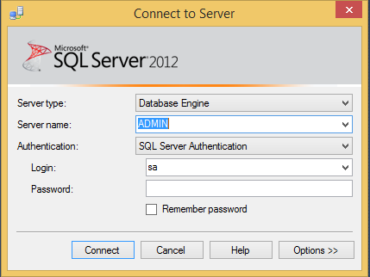

Step 2: Open AlluringDecors.sql file to setup database:

Menu File > Open > Files…

Select AlluringDecors.sql file in Team4 > database, click Open.

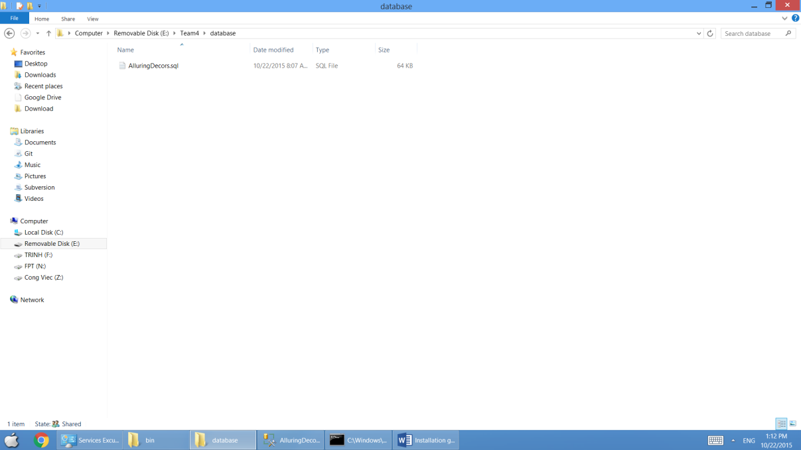

Execute AlluringDecors.sql file to create AlluringDecors database (Click Execute button on toolbar or Press F5 on keyboard).

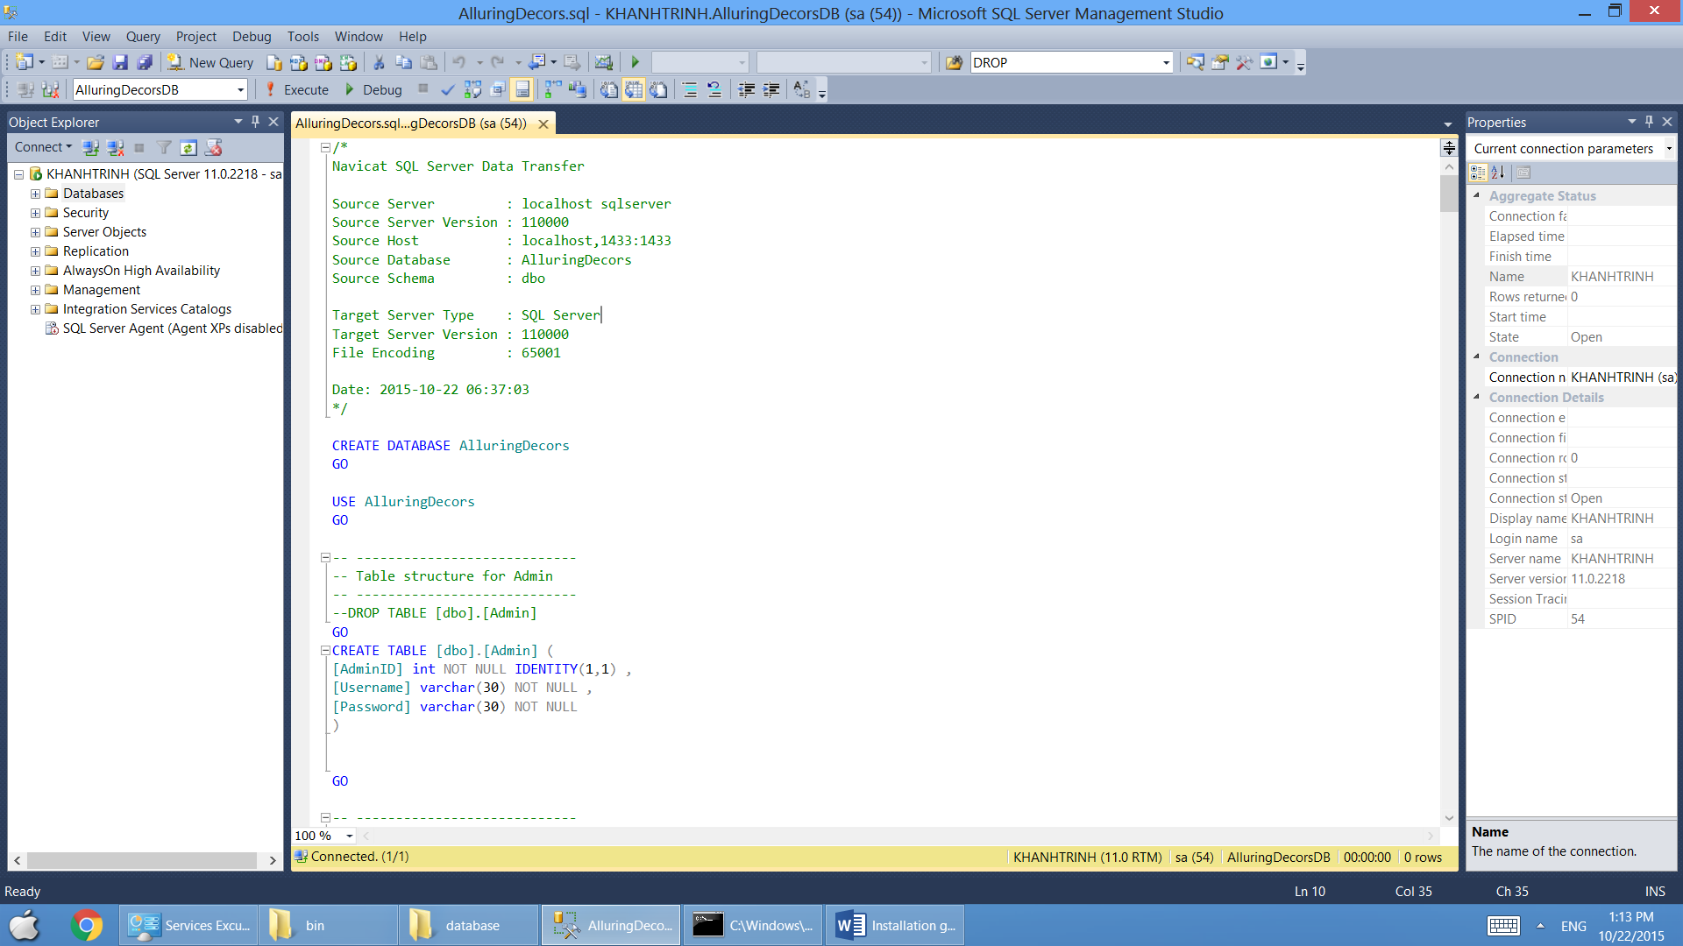

Right Click Databases > Refresh.

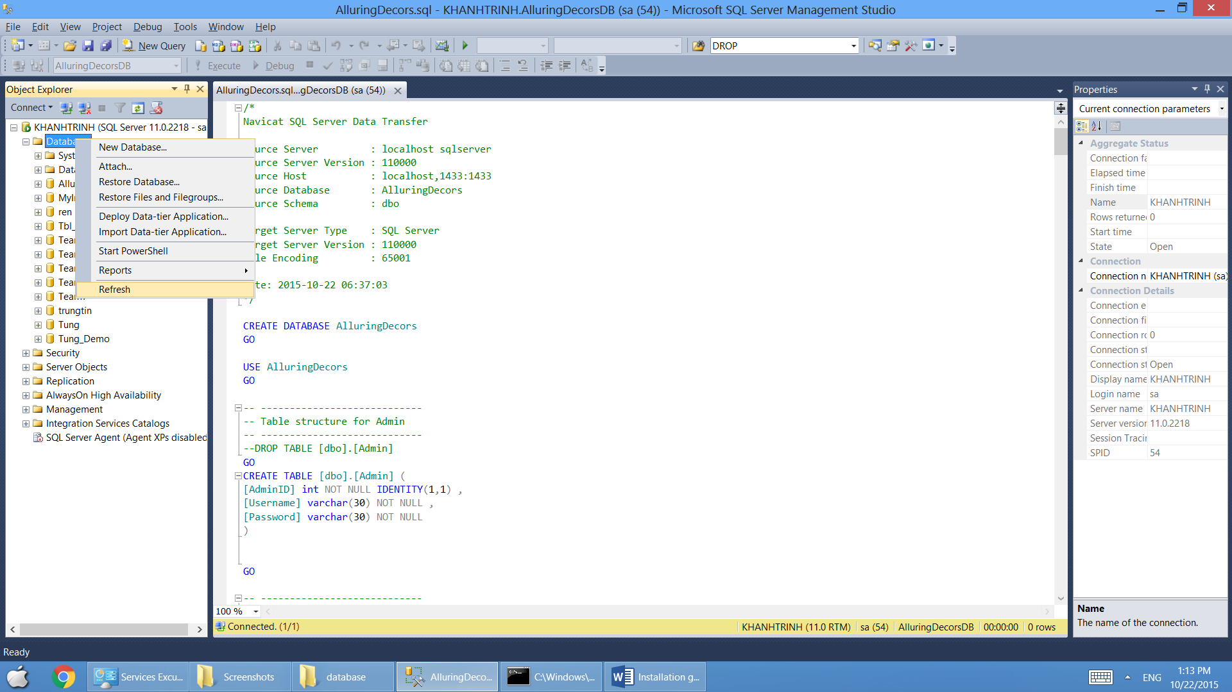

Result: appear the AlluringDecors database in Databases folder.

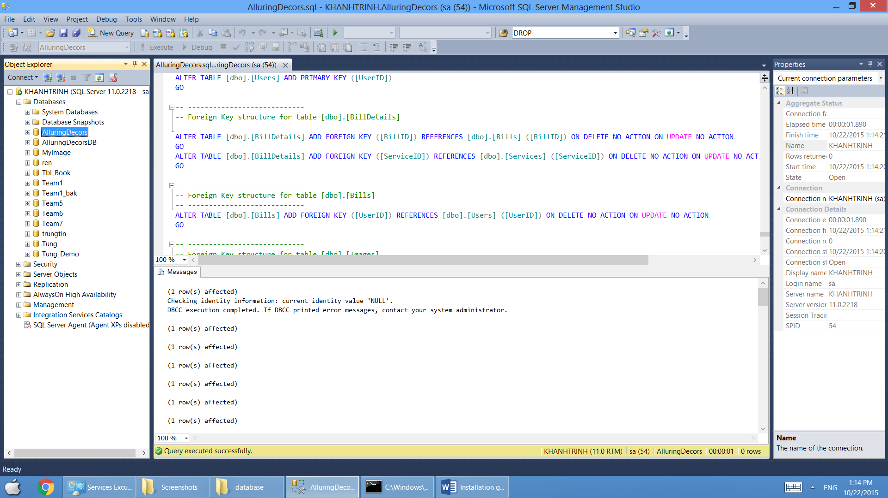

Create database successfully.

1. **Setup J2EE application with glassfish 4.0:**
   1. **Configuration glassfish 4.0:**

Download GlassFish 4.0 <http://download.java.net/glassfish/4.0/release/glassfish-4.0.zip>

or copy from setup CD.

Extract file glassfish-4.0.zip.

Copy file in ***Soft\Lib\sqljdbc4.jar*** into ***glassfish4\glassfish\domains\domain1\lib***

Run file ***glassfish4\glassfish\bin\asadmin.bat*** and typing command: ***start-domain***

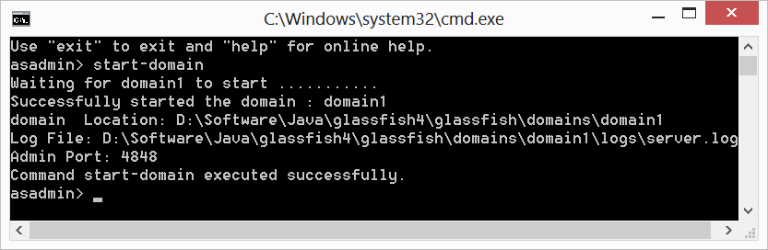

Note: Does not close cmd window during the running applications.

Open web browser with following link: <http://localhost:4848/>

Choose create New JDBC Connection Pool (or Resources>JDBC>Connection Pools>New)

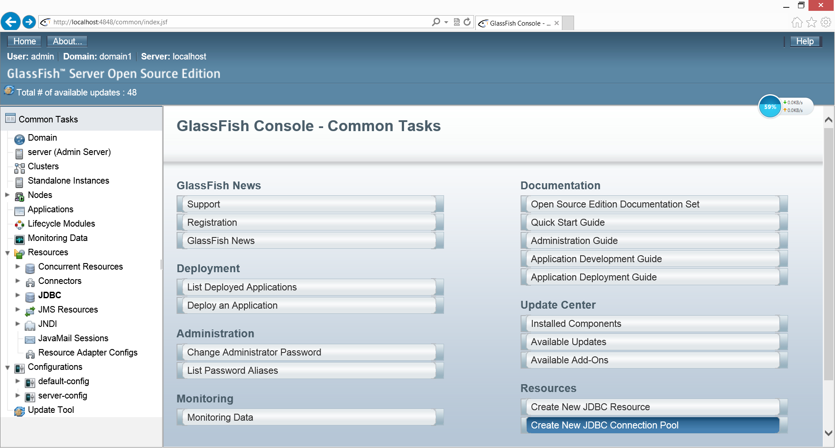

Step 1: Fill text fields with following information:

Pool Name: ***microsoft_sql_AlluringDecors_saPool***

Resource Type: ***javax.sql.DataSource***

Database Driver Vendor: ***MicrosoftSqlServer***

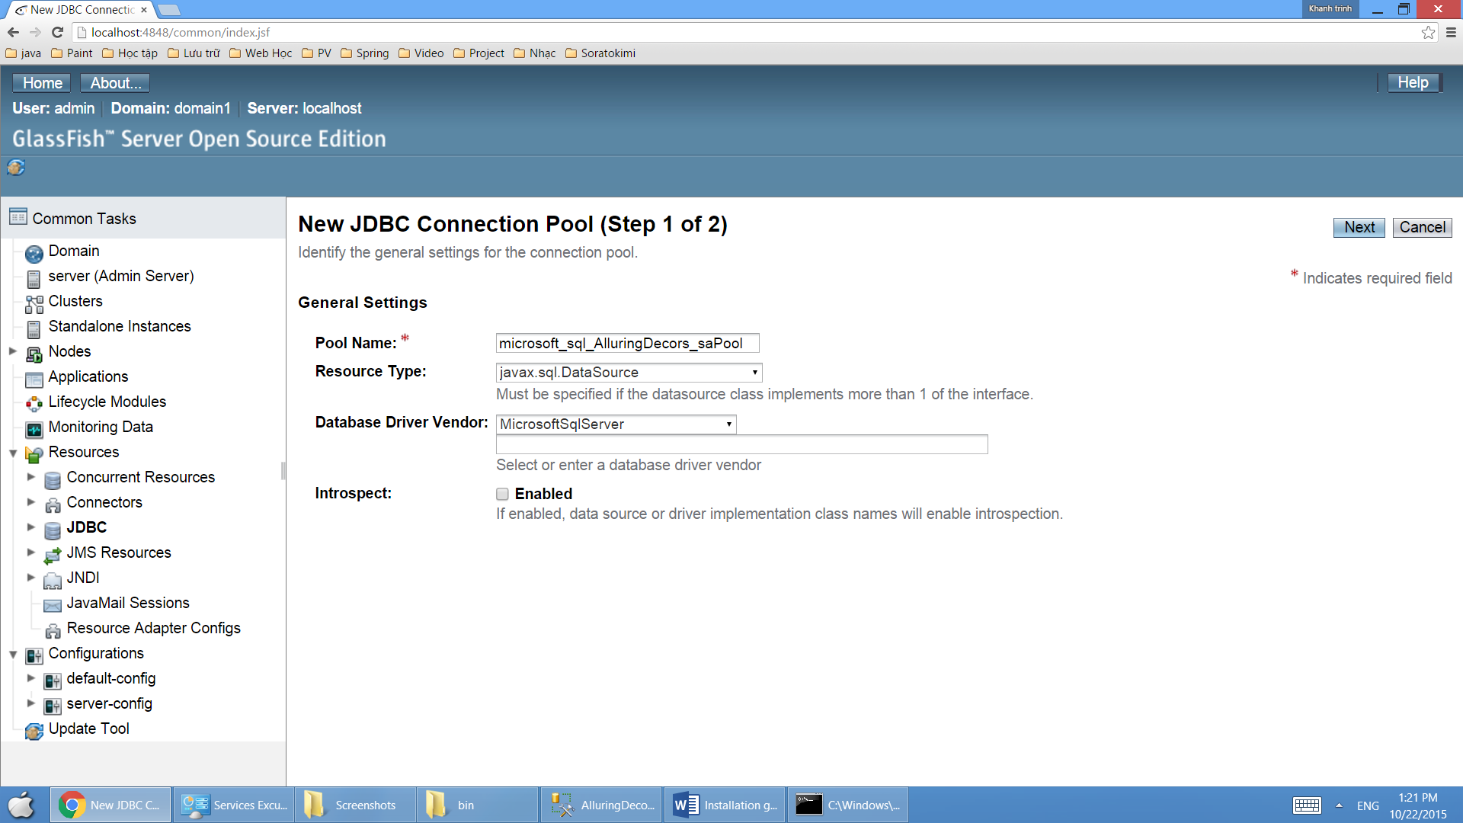

Click Next.

Step 2: Fill text fields with following information

User: ***sa***

Password: ***123***

URL: ***jdbc:sqlserver://localhost:1433;databaseName=AlluringDecors***

Note: GlassFish required password with connection to SQL (To use an empty password, edit the file glassfish4\glassfish\domains\domain1\config\domain.xml).

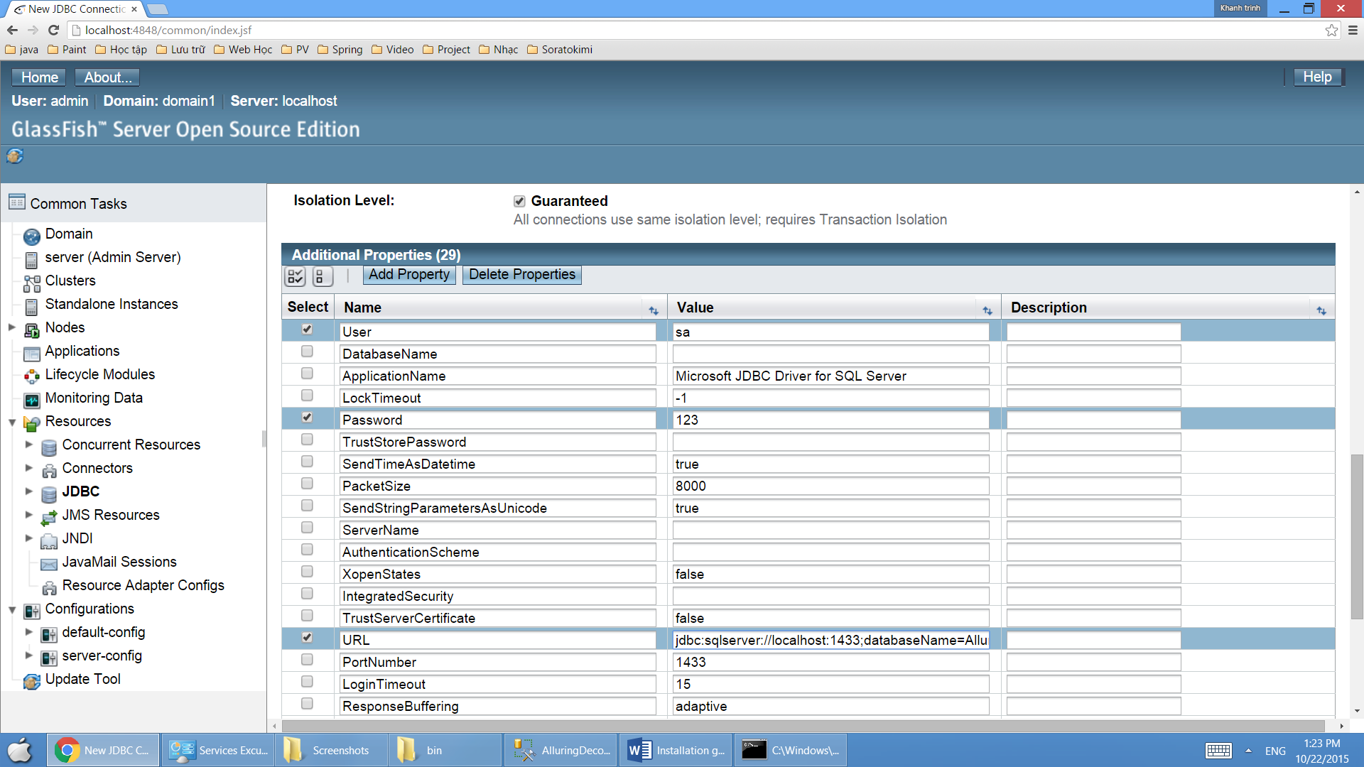

Click Finish to create JDBC Connection Pool.

Click ***Ping*** to test connection.

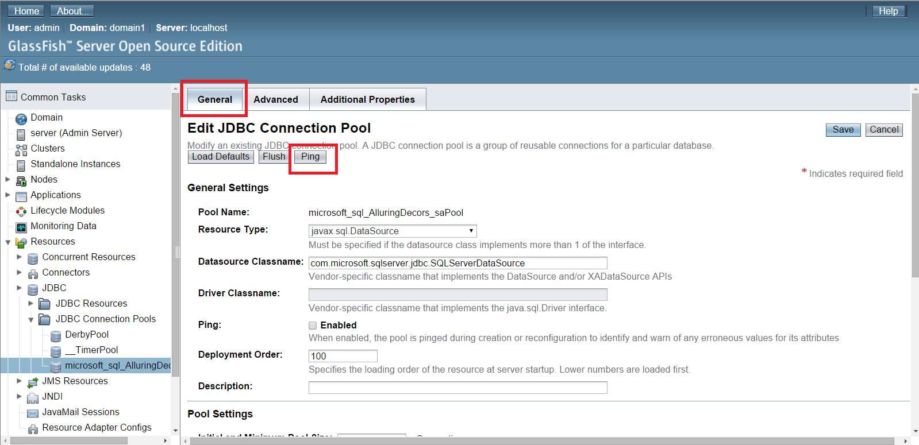

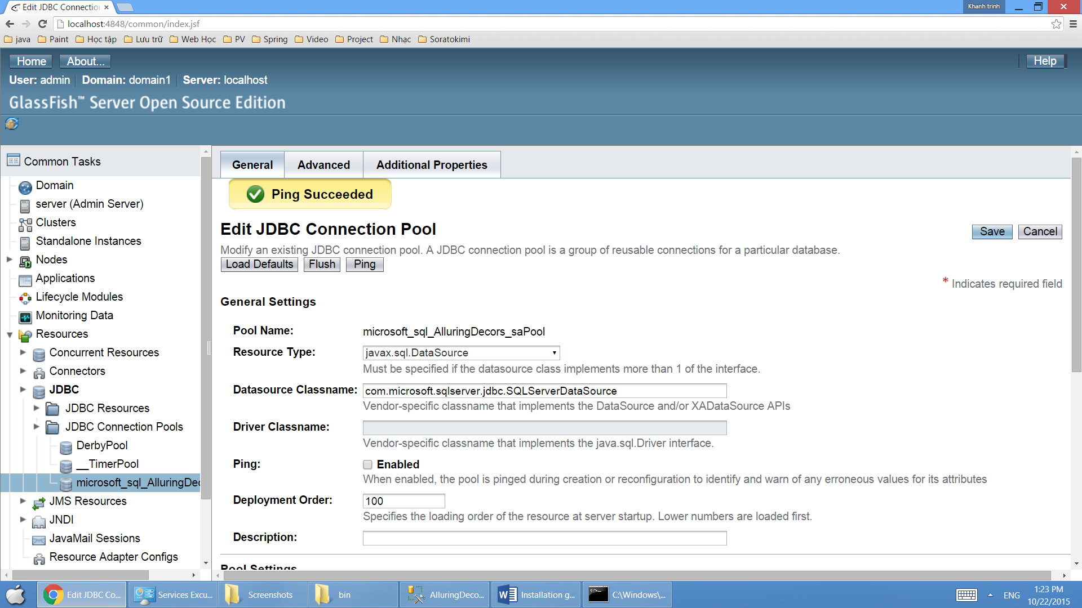

Choose New JDBC Resources (or Resources>JDBC>JDBC Resources>New)

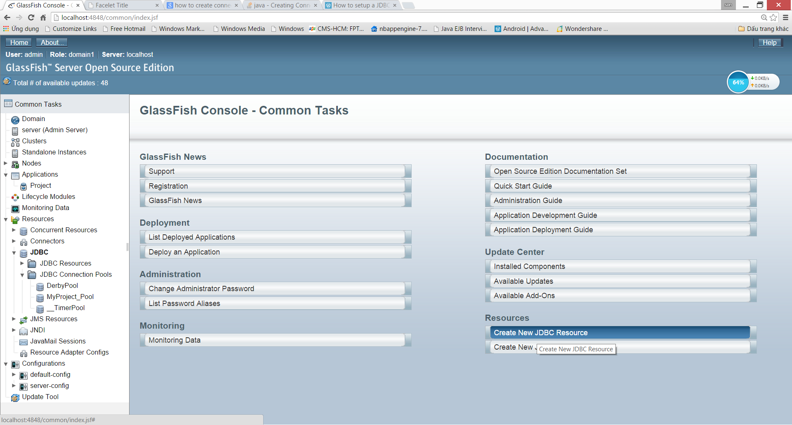

Fill text fields with following information:

JNDI Name: Team4

Pool Name: ***microsoft_sql_AlluringDecors_saPool***

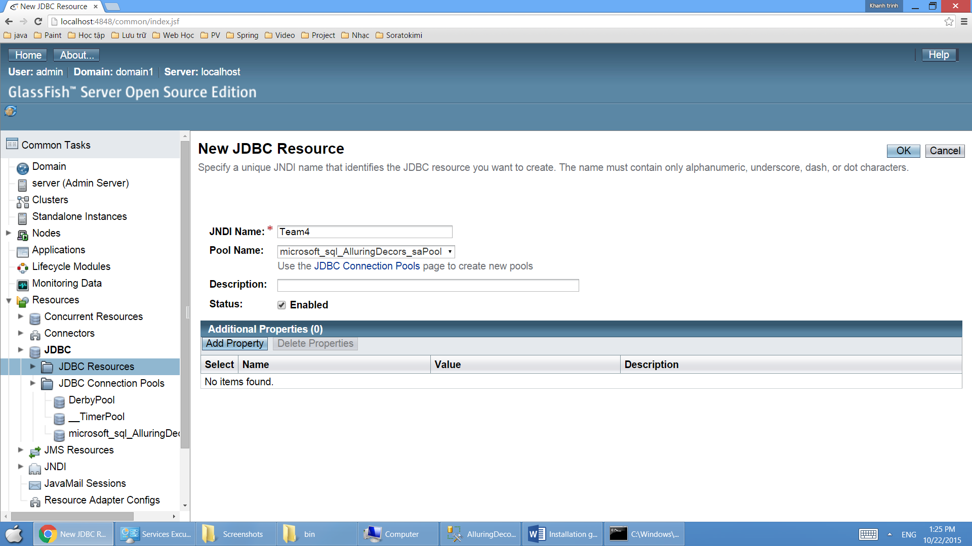

Click Finish to create JDBC resource.

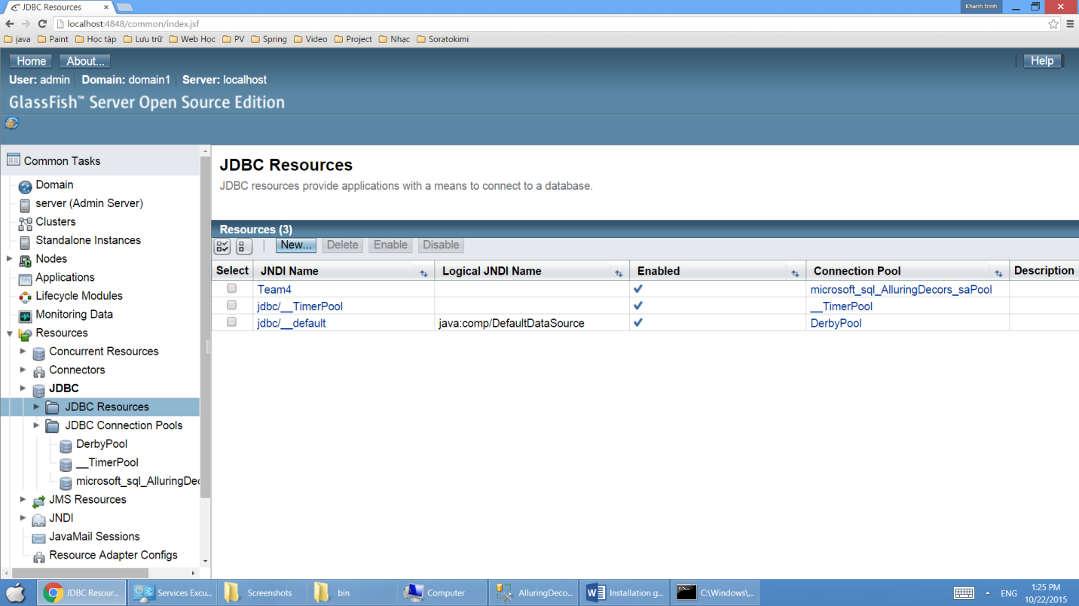

* 1. **Deploy application:**

Choose Deploy an Application (or Applications>Deploy)

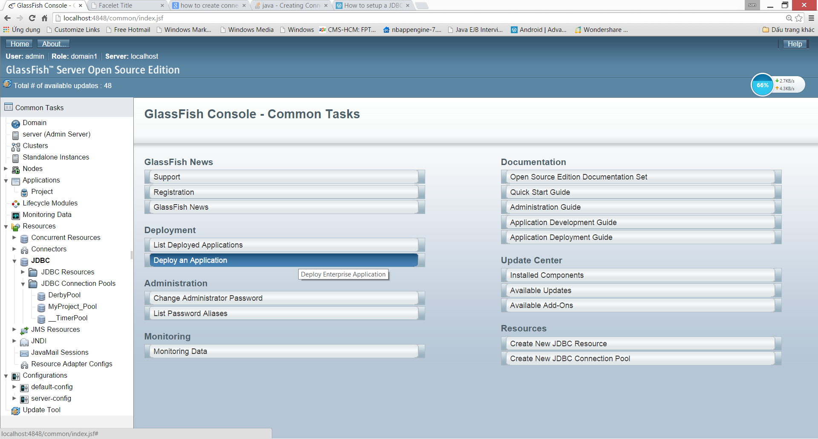

Select file ***Team4\dist\Team4.war*** and click OK to deploy application.

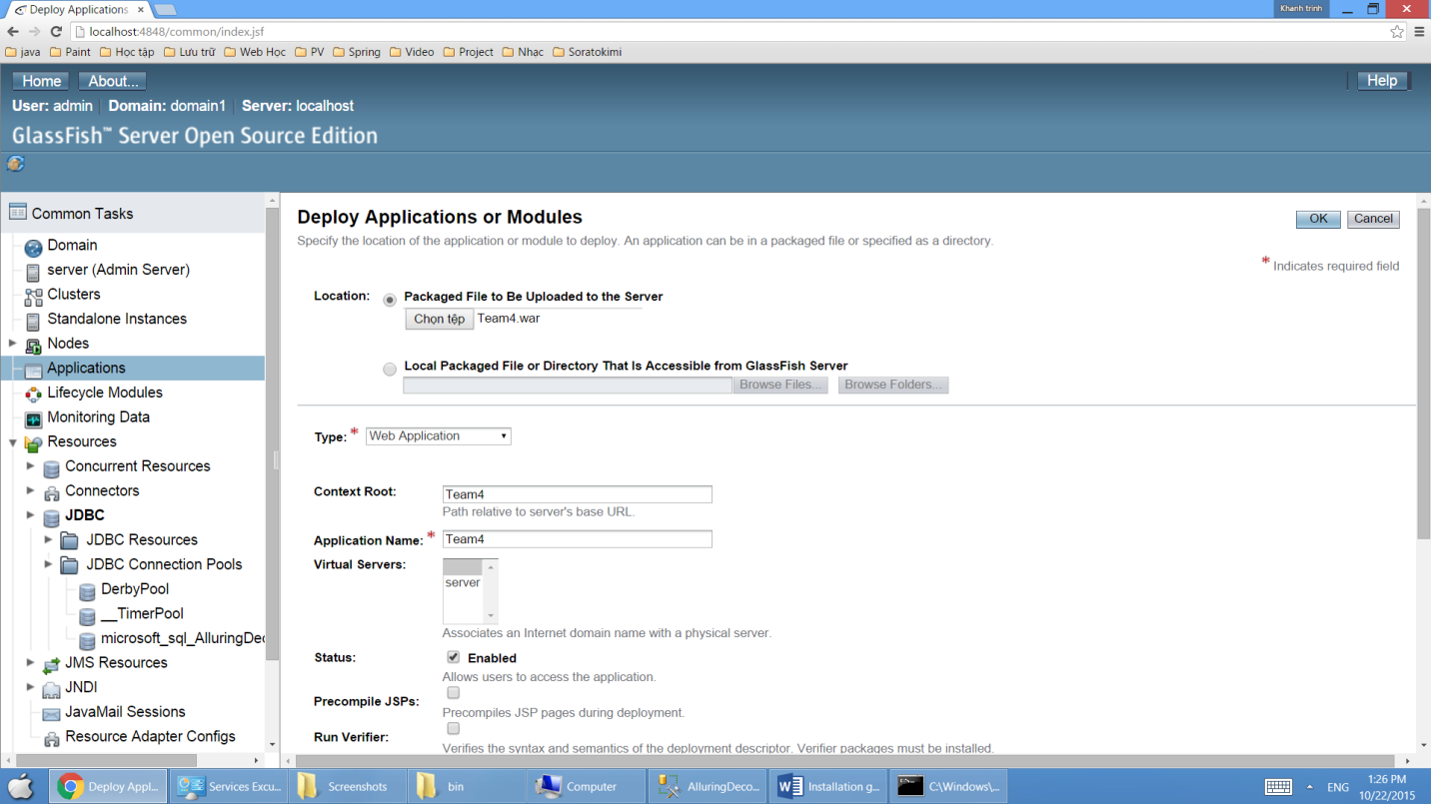

Choose Application > Team4 to open application.

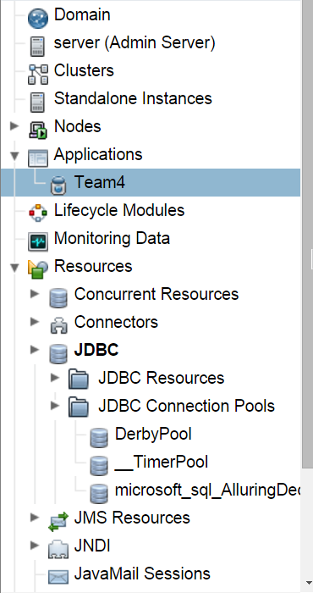

Click Launch to launch application.

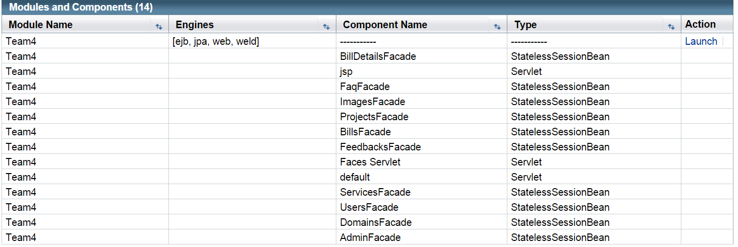

Click [http:// *tên máy*:8080/](http://admin:8080/MSProject-war)Team4 link. Then the first web page will appear for you.



**Run Website on Browser:**

Go to Internet browser type: http:// *tên máy*:8080

[http:// *tên máy*:8080/](http://admin:8080/MSProject-war)Team4/Login.xhtml **for user login.**

[http:// *tên máy*:8080/](http://admin:8080/MSProject-war)Team4/admin/Login.xhtml **for admin login.**

Login website:

* Customer account:

Username: DucAnh Password: 123456

Username: ChiDat Password: 123456

* Admin account:

Username: Admin Password: 123